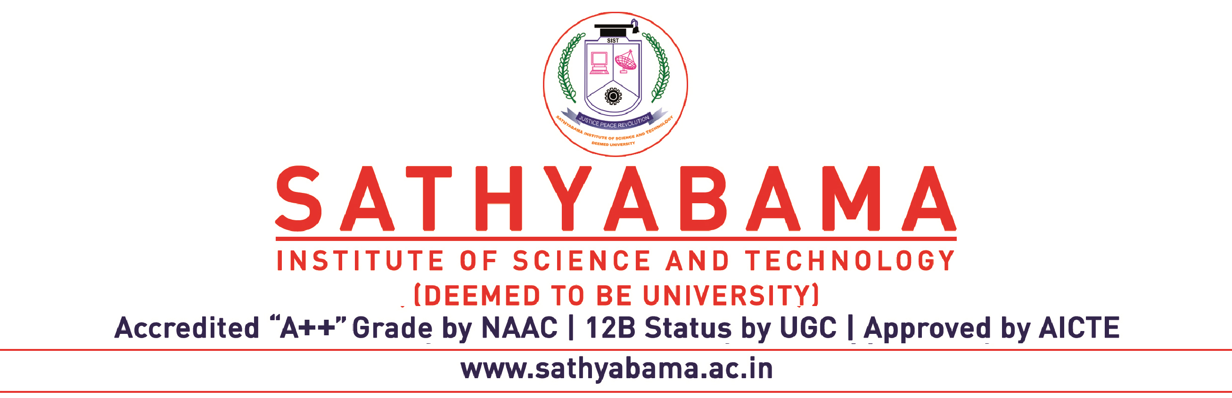

Date:
APPLICATION FORM FOR SIMILARITY INDEX CHECK OF ARTICLE

1. Name of the Candidate :
(Block Letters)

2. a)Designation and Name & Address :
of the organization

b)Address for Correspondence :

Mobile no :

E-mail.ID:

3. Details of the document : Title:

4. Whether Soft copy of the document in pdf enclosed: Yes ( ) No ( )

6. No. of pages :

7. Fee Details :

8. Date of submission of Details :

9. Date of Receipt of Report :
(1 week from date of submission)

Signature of the Candidate/ First Author Signature of Co- Authors

--------------------------------------------------------------------------------------------------------------------------------------------------------------------
Plagiarism Check Fee:
Rs. 250/- for pages 1 – 10
Beyond 10 pages @Rs.10/- per page

Note: Kindly send the soft copy to deanresearch@sathyabama.ac.in [Mail ID]

